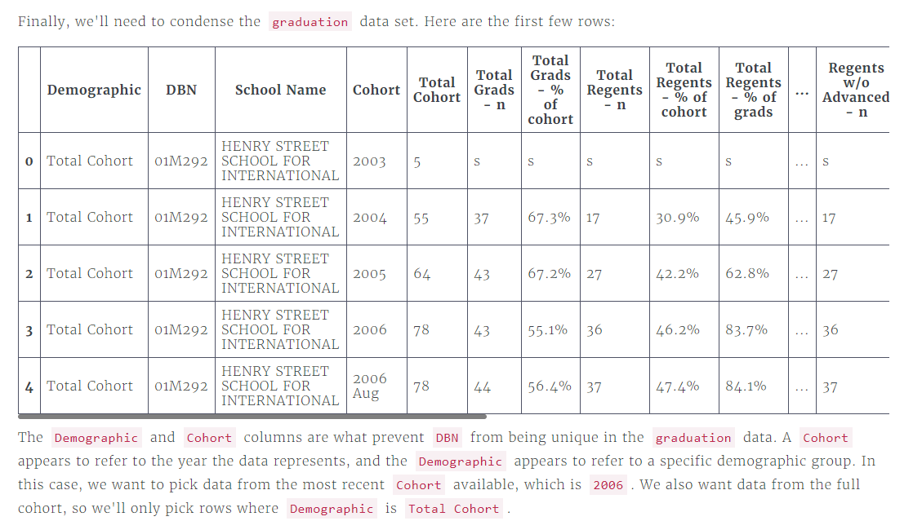

* Filter graduation, only selecting rows where the Cohort column equals 2006.
* Filter graduation, only selecting rows where the Demographic column equals Total Cohort.
* Display the first few rows of data["graduation"] to verify that everything worked properly.

data["graduation"] = data["graduation"][data["graduation"]["Cohort"] == "2006"]

data["graduation"] = data["graduation"][data["graduation"]["Demographic"] == 'Total Cohort']

print(data["graduation"].head())